**SOUTHWELL TOWN WALK**

**SOUTHWELL**

**TOWN COUNCIL**

1. From Church Street car park, turn left following the trail past important Georgian buildings, such as the North Muskham Prebend, Cranfield House and the Woodborough Prebend.
2. You will eventually reach Bramley Tree Cottage. The original Bramley apple tree still stands in the back garden. It was planted in the early 1800s, enabling local nurseryman, Mr Merryweather, to establish the now famous variety.
3. Arriving at Burgage Green via Shady Lane, you will be confronted by the daunting gateway to The House of Correction, built in 1807. Although this is well preserved, most of the prison has long since disappeared.
4. Close by is Burgage Manor, which was occupied by Lord Byron and his mother between 1804 and 1806. Following the trail past the Wheatsheaf Inn and the Market Square will lead you along King Street to Queen Street.
5. In the Old Market Place is Southwell's Georgian Theatre, now the Old Theatre Deli. Lord Byron is said to have taken part in amateur theatricals here. Close by is The Saracen's Head, a well-known Southwell landmark. This inn is where Charles I spent his last few hours of freedom in 1646 before giving himself up to the Scottish Commissioners.
6. Follow the trail along Westgate past the Gothic style Sacrista Prebend and the 17C Rampton Prebend to Bishop's Drive, arriving at Bishop's Manor. In 1907 the Manor was built into the ruins of the old Bishop's Palace, which dates back to the 1400s. Cardinal Wolsey spent his last summer there in 1530, while Charles I retreated to the Palace after defeat at the Battle of Naseby in 1645.
7. The Southwell Minster has been the Cathedral Church of Nottinghamshire since 1884. The first sight is the massive Norman Nave but as you move around the Church you become aware of the delicacy of the 13C Chapter House carvings and the Gothic Quire.

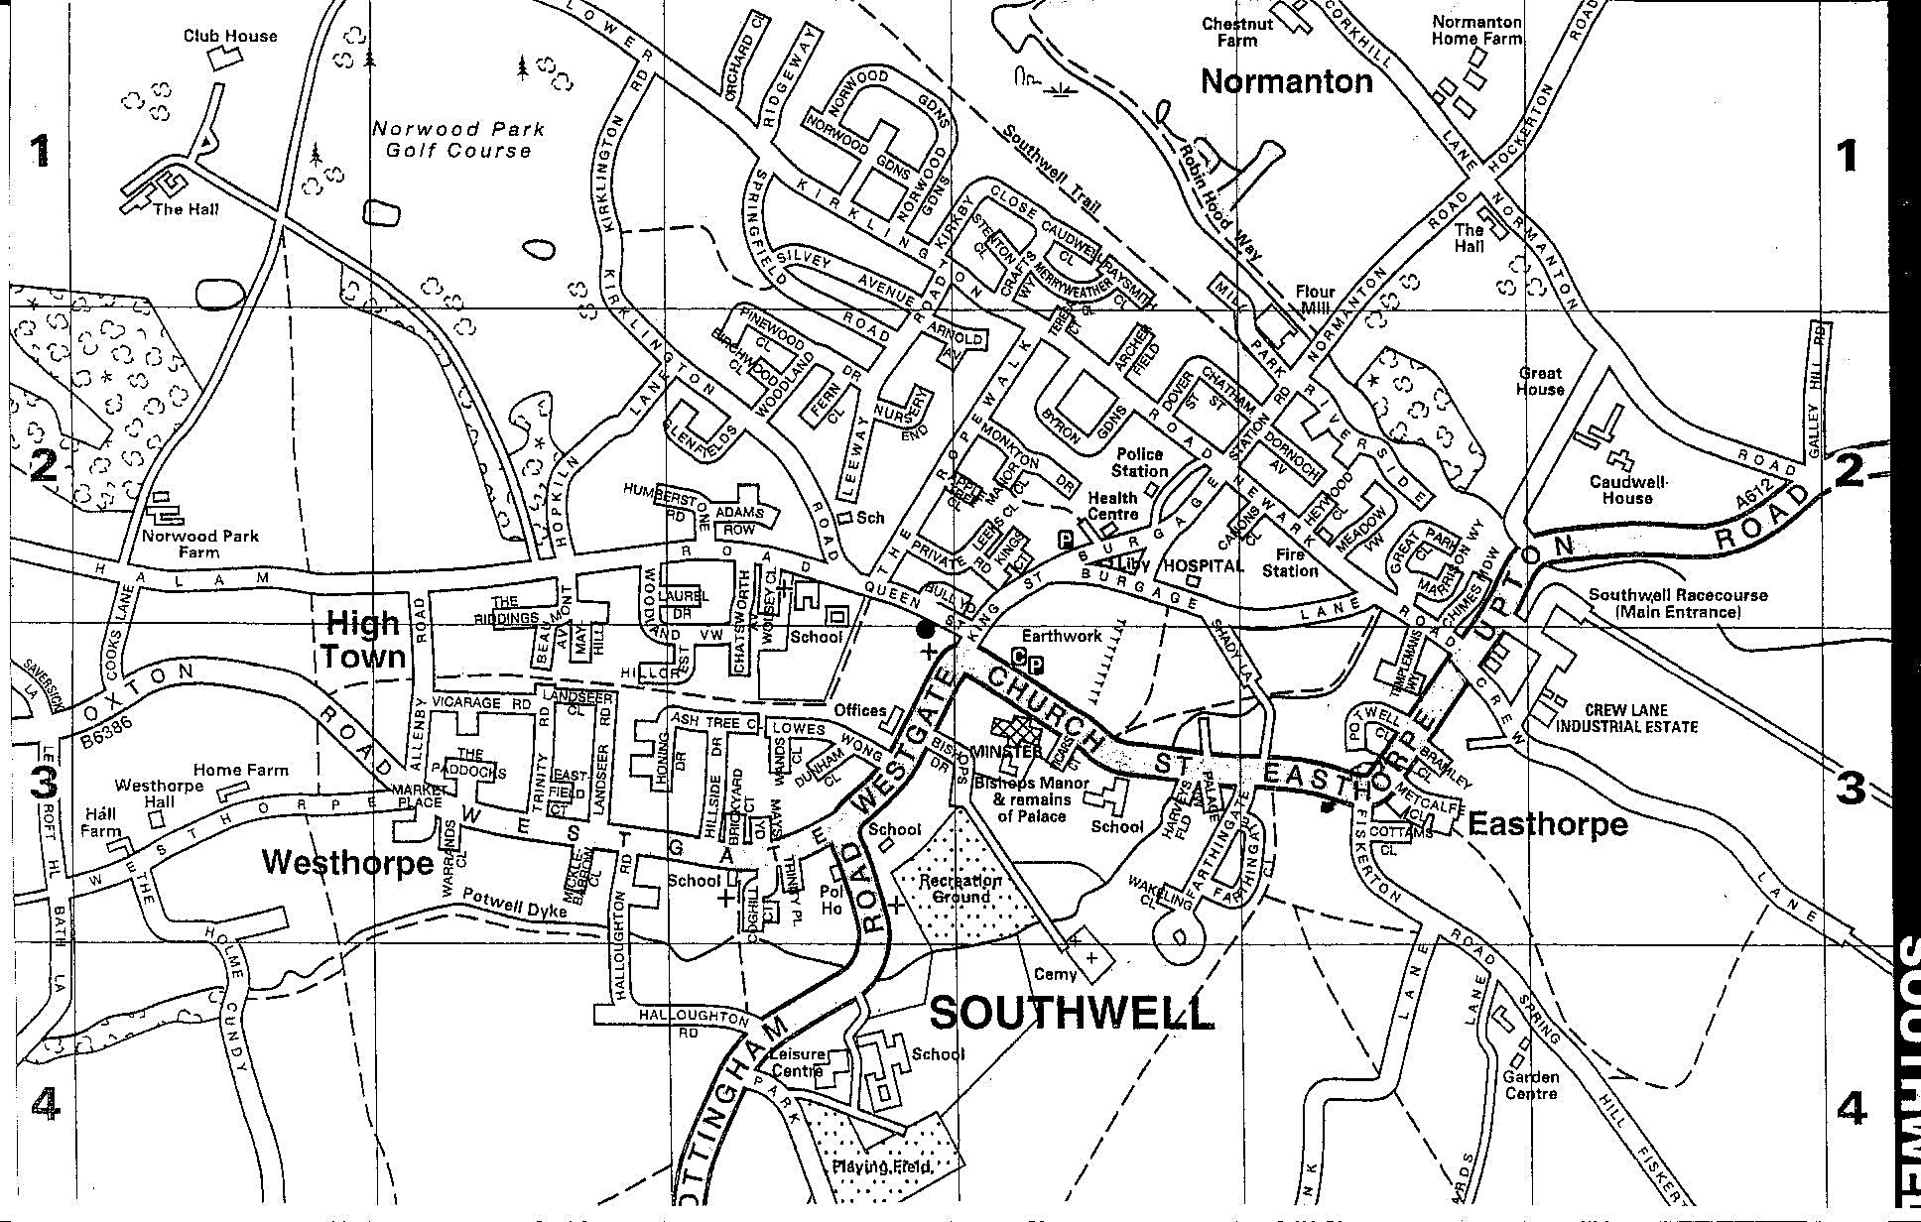

**2**

**7**

**6**

**5**

**4**

**3**

**1**